This Kit makes a great birthday or Christmas present!
$25.00
How to Get Started in Genealogy:
A Research Tool Kit
Perfect for the beginning Genealogist!
Perfect for the seasoned genealogist to take on the Road!
Everything you need all in one place!
What’s included in the Kit:
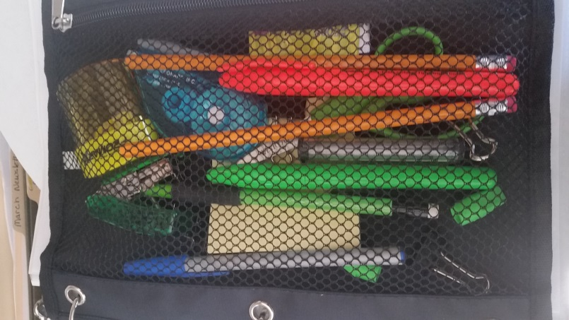  - 1 Thumb Drive  - 1 Post-It Note  - 1 Mechanical Pencil  - 1 Tube Mechanical Lead & erasers  - 2 pencils  - 1 Pencil Sharpener  - 1 Stapler  - 1 Box Staples  - 1 Black & 1 Blue Pen  - 1 Orange Highlighter  - 5 Small Clips  - 1 Scissor  - 1 Correction Tape | - Good Questions for Family Interviews  - Research Check List  - Ancestor Chart  - Family Unit Chart  - Family Group Record  - Cemetery Record  - Cemetery Transcription Form  - Facts Inventory List  - Census Inventory List  - 1790 US Federal Census Log  - 1800 US Federal Census Log  - 1810 US Federal Census Log  - 1820 US Federal Census Log  - 1830 US Federal Census Log  - 1840 US Federal Census Log  - 1850 US Federal Census Log  - 1860 Census Log  - 1870 US Federal Census Log  - 1880 US Federal Census Log  - 1890 Veterans Schedule  - 1900 US Federal Census Log  - 1910 US Federal Census Log  - 1920 US Federal Census Log  - 1930 US Federal Census Log  - 1940 US Federal Census Log  - Military Service Record  - Military Records Checklist  - 1 Ruled Subject Notebook

